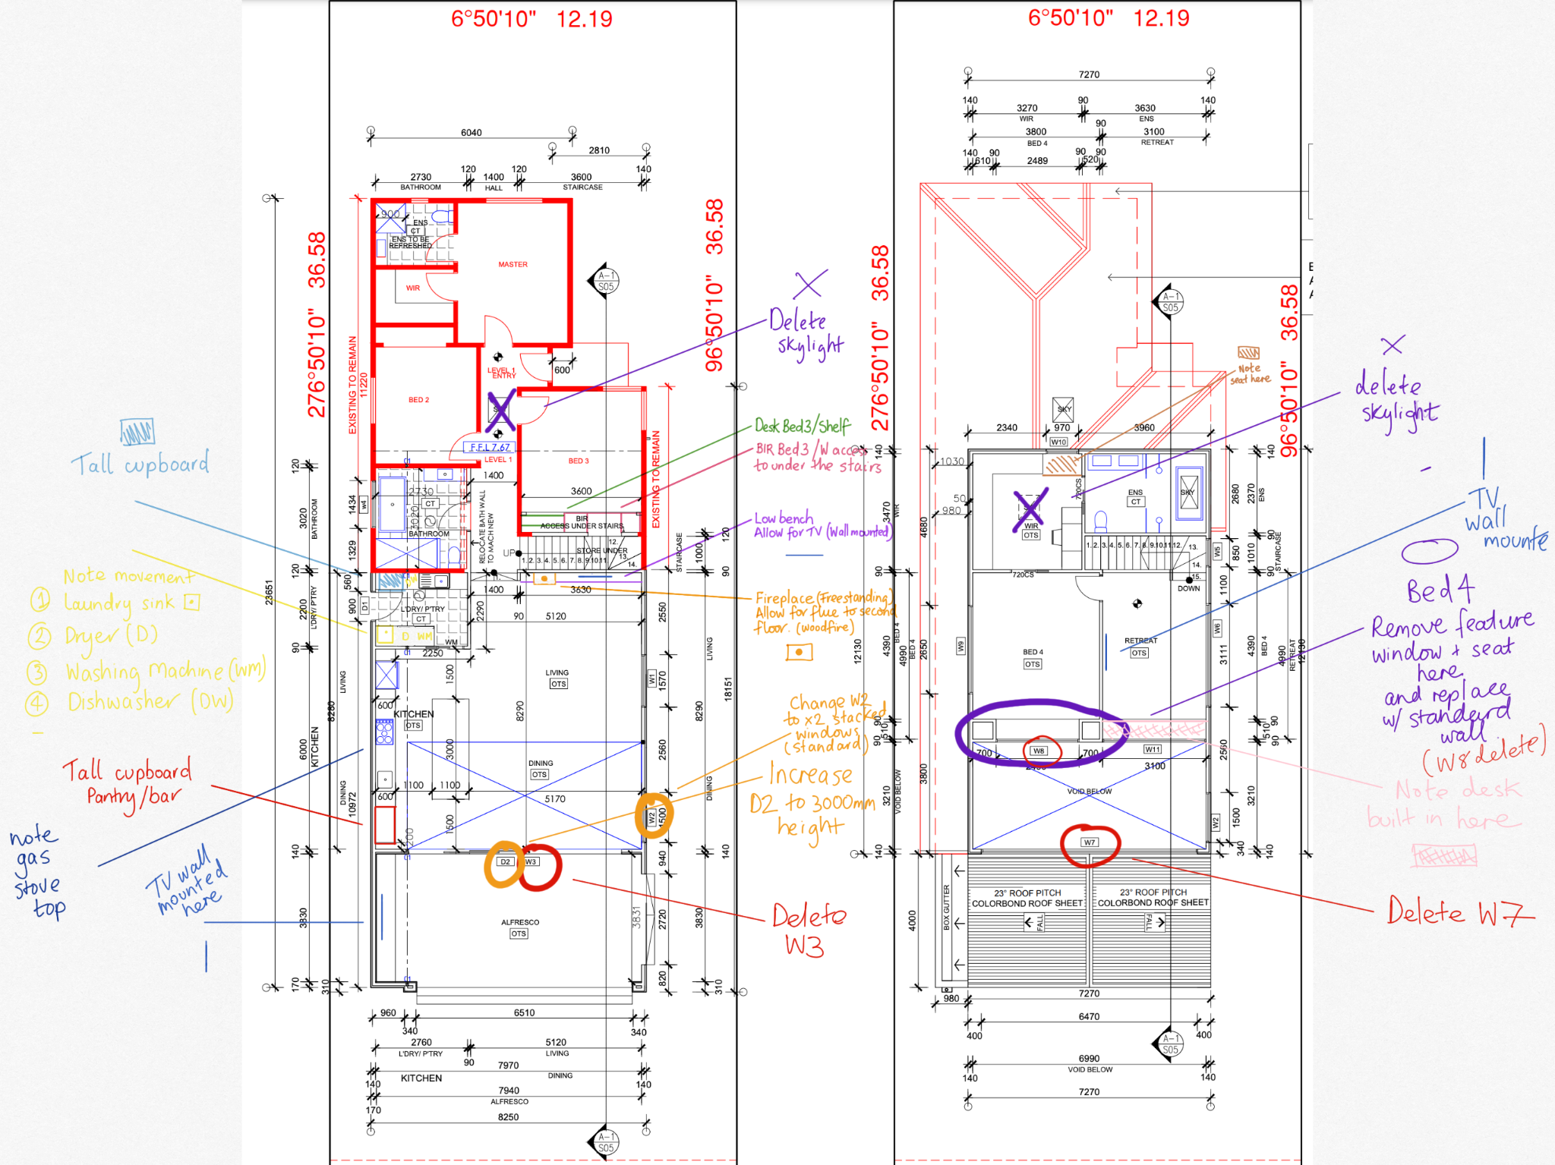

Notes for Archiscale

Overall:
- Delete skylight in hallway + WIR and leave x1 in upstairs ensuite
- Update lighting plan as per notes
- Update GPO’s as per notes
- Please add new GPO’s on original part of the house as per drawings
- Please add electrical notes on existing house as per notes as these are being replaced
Laundry/Pantry
- Add laundry sink next to WM + Dryer per notes above
- Note Dishwasher to left of sink per notes above
- Note tall cupboard in Laundry/pantry per notes above
Bedroom 3
- Bedroom 3 | Note BIR w/ desk with access to under stairs
- Please add light connection (wall mounted) and GPO under the stairs
Windows
- Windows- delete w7 and w3 as well as w8.
- Amend w2 to 2 standard windows stacked to save costs
Doors
- Extend stacked doors (D2) to 3000mm in height
WIR NEW (Upstairs)
- Note small seat in upstairs WIR behind window
Kitchen
- Note gas connected stove top in kitchen
- Point POD powerpoint to be added to island bench
- Note tall cupboard (Pantry/bar) to kitchen as per notes
Living
- Add bench seat to West wall in living running full length to allow for fireplace to sit on.
Fireplace specified as: https://fire4u.com.au/product/adf-linea-85b-freestanding-wood-fireplace/
- Wood Fireplace to be added to the West wall in living on LHS when facing wall to sit on bench
- Please allow for space in wall going upstairs for flue, we realise this will impact the door from the retreat to bedroom moving slightly east.
- Please move GPO’s, Internet etc. across away from fireplace, TV will be wall mounted.
Master bedroom (Upstairs)
- Master bedroom upstairs window W8 and seat to be removed
Retreat
- Add to retreat note for built-in desk along the east wall full length
- Note TV will be wall mounted on South wall
Alfresco
- Note TV to be wall mounted on South wall

